Write queries (a) to (d) based on the tables EMPLOYEE and DEPARTMENT given below and output for (e):

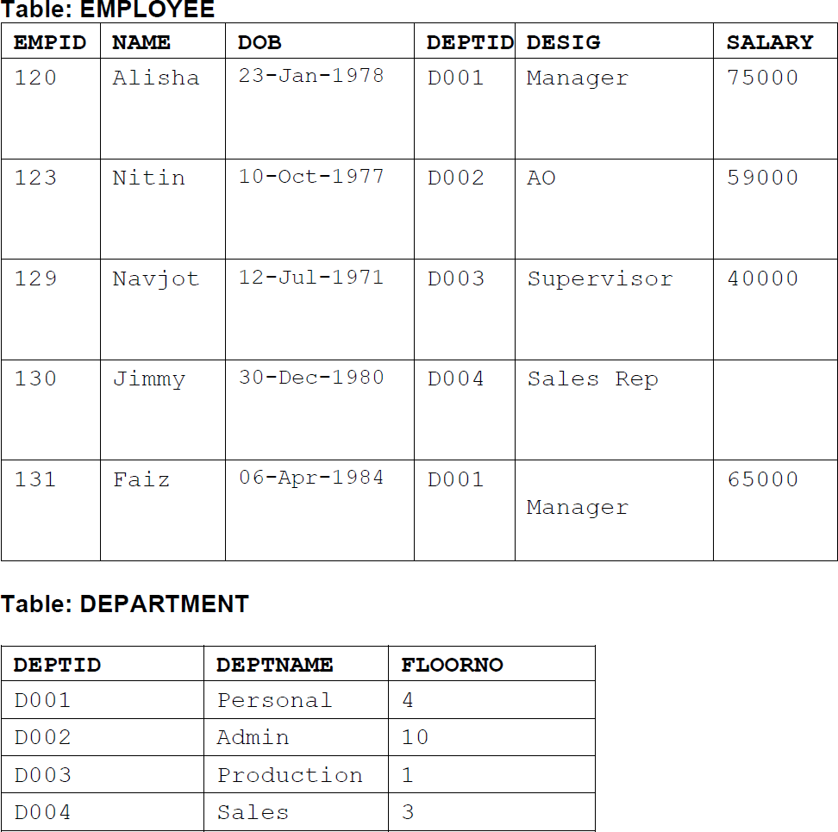

1. **To display the average salary of all employees, department wise.**
2. **To display name and respective department name of each employee whose salary is more than 50000.**
3. **To display the names of employees whose salary is not known, in alphabetical order.**
4. **To display DEPTID from the table EMPLOYEE without repetition.**
5. **Select MAX(SALARY),DESIG from employee group by DESIG;**

QUERIES AND OUTPUT:

a.

SELECT AVG(salary) From EMPLOYEE,DEPARTMENT WHERE EMPLOYEE.DEPTID=DEPARTMENT.DEPTID GROUP BY DEPARTMENT.DEPTNAME;

b.

SELECT NAME,DEPTNAME From EMPLOYEE,DEPARTMENT WHERE EMPLOYEE.SALARY>50000 AND EMPLOYEE.DEPTID=DEPARTMENT;

c.

SELECT NAME FROM EMPLOYEE

WHERE SALARY IS NULL ORDER BY NAME ;

d.

SELECT DISTINCT(DEPTID) FROM EMPLOYEE;

e.

|  |  |
| --- | --- |
| **MAX(SALARY)** | **DESIG** |
| 75000 | MANAGER |
| 59000 | AO |
| 40000 | SUPERVISOR |
| NULL | SALES REP |